100818 Mass Spec PCB Design Verification Testing

Microcontroller Programming.

Setting Fuses.
Both microcontrollers need to have their fuses (configuration bits) set. This cannot be done through MPLAB IPE, but must be done through Microchip Studio, which only runs in Windows.

Fuse Settings to Use are below:

Atmega2560
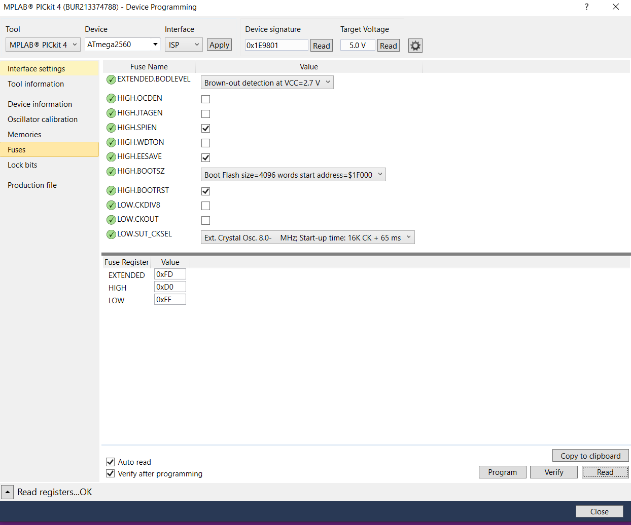

Atmega16U2
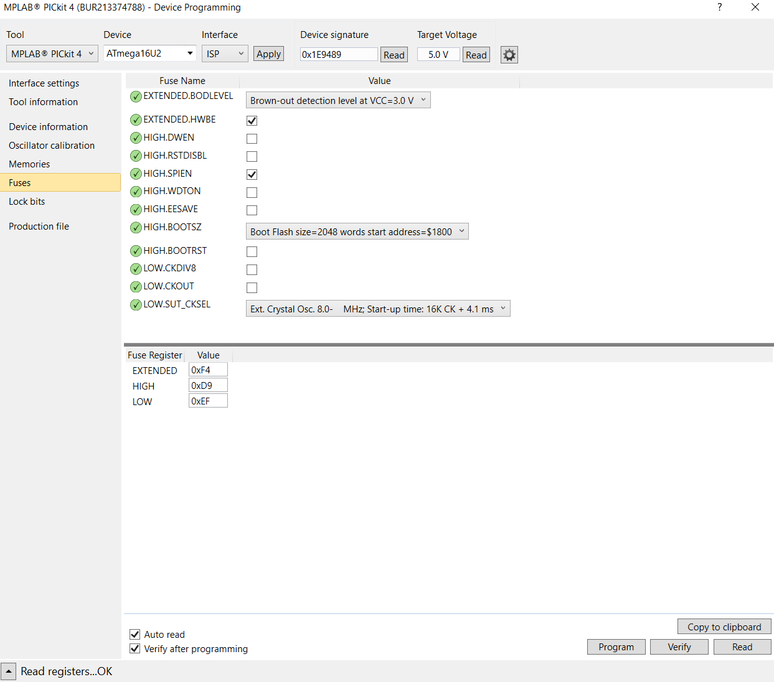

Programming Firmware
ATmega16U2_read.hex

2560-blank.hex

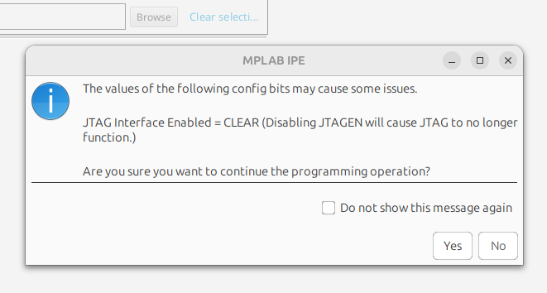
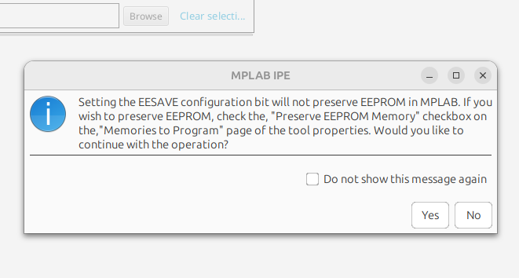

Power Supply Testing

24V #1 @6.9A (Mass Spec and Turbo pump)
Connected Vin to 2x 30V supplies to share load.
Tested with Variable load up to 7A. Regulation maintained throughout loading.

24V #2 @ 2.5A (MVP)
Connected to 1X 30V supply. Soldered wire to output of regulator (bypassing switch).
Verified 24V output at 18V input and 31V input.

Verified with 2.5A load @31V.
Verified with 2.5A load @18V.

12V @ 500mA (CFP)
Connected to 1X 30V supply. Soldered wire to output of regulator (bypassing switch).

Verified 12V output at 500mA @18V
Verified 12V output at 500mA @31V

Comm Port Verifications

Used attached ardiuno code to echo back the received character plus 1 (this removes the possibility of a loopback short) on485, console and pico.

Note: Pico required a 3.3v regulator to be added next to U9 in order to function properly.

